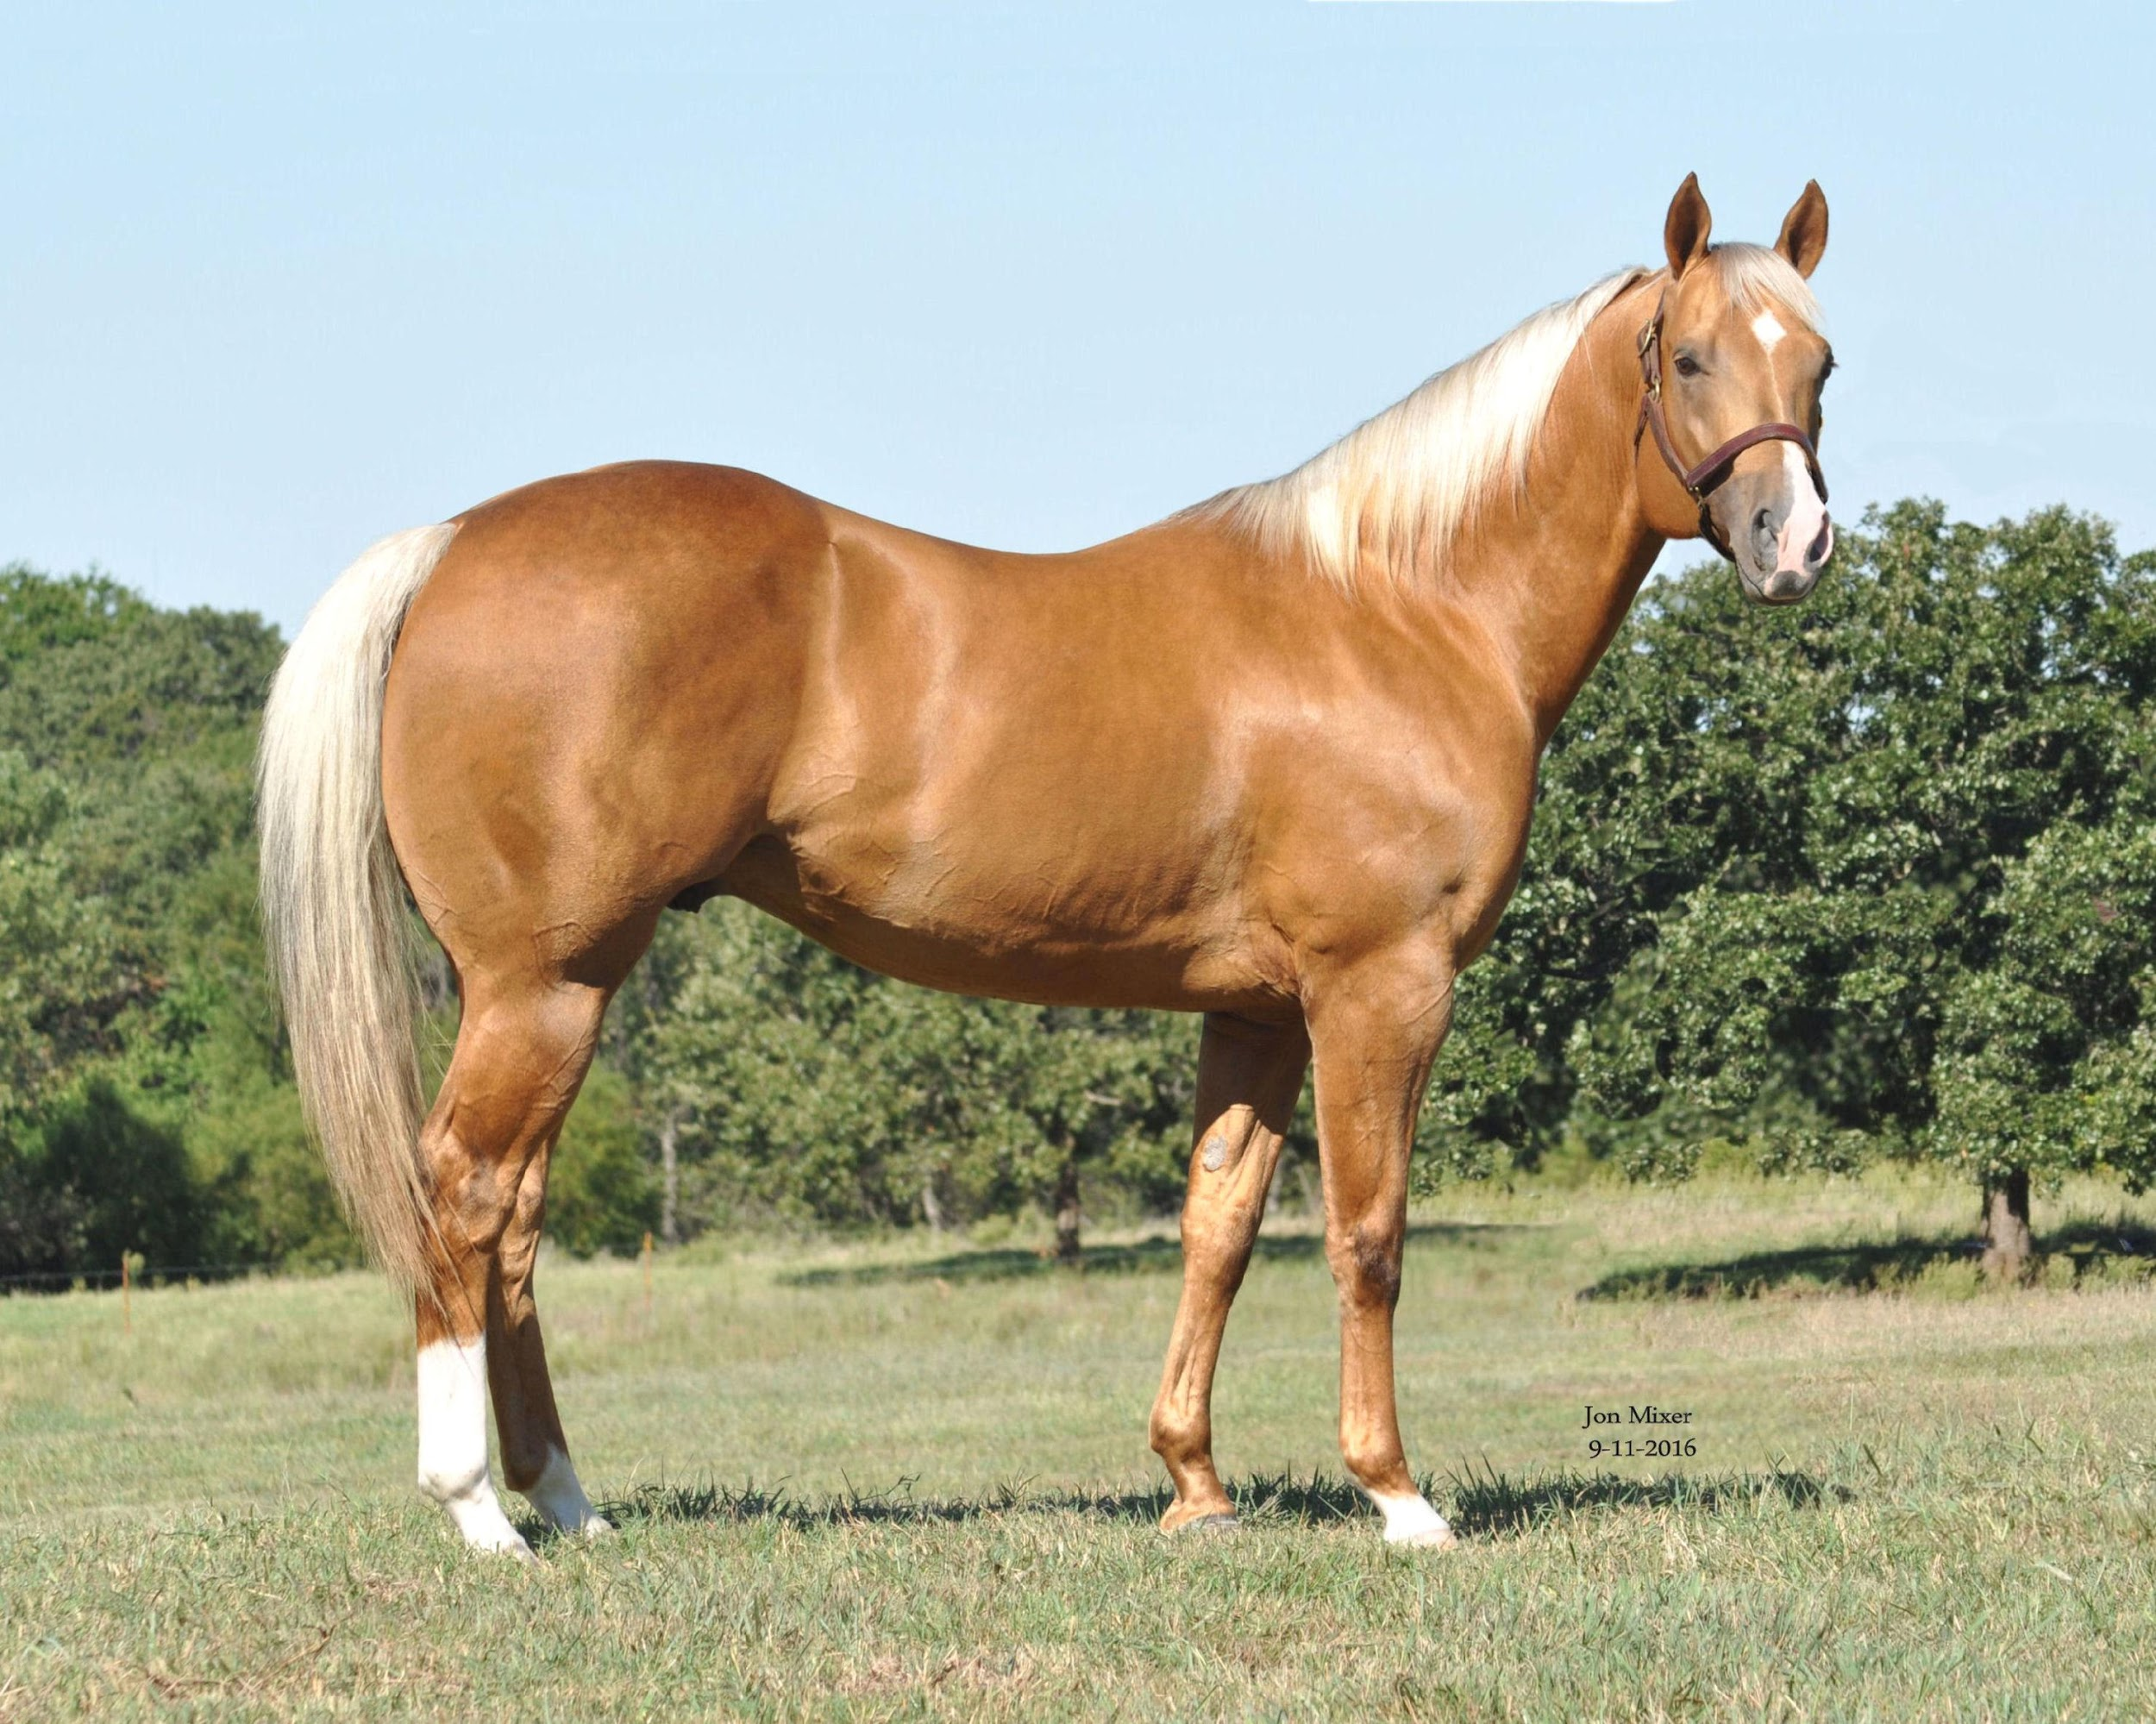
Owners: Heide Veterinary Services
Greg & Katie Torgerson 38262 Range, Road 13
PO Box 99 Red Deere County, ABT4E0J9
Richfield, UT 84701 Phone: 403-341-3875
Phone: 435-231-1611 (Greg) Email: heidevet@hotmail.com
Email: pcrpinkcadillac@gmail.com Website: heideveterinary.com
Manager Phone: 208-481-0258 (Kortnee)

*PLEASE EMAIL CONTRACT TO PCRPINKCADILLAC@GMAIL.COM*

2021 TECHNICOLOURS FROZEN SEMEN BREEDING AGREEMENT

1. PARTIES
This Agreement is made this _______day of _____________________, 20________by and between Greg Torgerson (Stallion Owner) and,

NAME (Breeder):_________________________________________
ADDRESS:____________________________________________________________
CITY:______________STATE:__________________ZIP:__________________
PHONE:___________________________________EMAIL:_____________________________________

Greg and/or Katie Torgerson are the owners of the stallion named TECHNICOLOURS, AQHA Registration #5053427.
Technicolours shall have frozen semen available with Heide Veterinary Services(HVS). HVS is legally authorized to act on behalf of the Stallion Owner for the purposes of arranging breeding services and entering into this
Agreement.

Breeder has ownership rights of, or warrants that s/he is legally authorized to arrange breeding services for the following mare:

MARE INFORMATION:
Registered name of mare:______________________________________________Age:____________
Registry: AQHA_________APHA________TB_________
Registration #: _________________________________Color:_______________________
Sire:_______________________________________Dam:__________________________________
Dam Sire:___________________________________
Current Status (circle): In Foal/Foaling Maiden Open Barren

A copy of the mare’s registration papers MUST be submitted with this agreement.
Will this be an embryo transfer breeding (circle): YES NO
If a breeding results in multiple embryos, a separate contract and breeding fee is required for each additional embryo. This agreement gives no guarantees for live foals from frozen embryos (Section 6).
2. TERM OF AGREEMENT
This breeding agreement is valid from the date executed above through the breeding season of the following consecutive year.

3. BREEDING FEES
Upon execution of this agreement the breeder agrees to pay the stallion owner the following fees. The breeder specifically agrees and understands that no semen will be shipped until all fees have been paid.

The 2021 frozen semen breeding fee, with live foal guarantee, for TECHNICOLOURS is $1500 US, which includes a booking fee of $500 US. All fees are non-refundable, subject to the availability of frozen semen.

Upon execution of this contract, stallion owner will invoice the breeder by email through QuickBooks. Payment may be submitted by Credit Card, PayPal, Venmo, or Check. Please make checks payable to Pink Cattle Company.

In the event the mare does not conceive during the first breeding season or for any other reason, if the breeder exercises the right to a return breeding pursuant to the ‘Live Foal Guarantee’ section hereof, the breeder shall pay the stallion owner a new booking fee of $500 US prior to the first breeding of the following year.

The conditions of the ‘Live Foal Guarantee’ are outlined in section 6.

PLEASE NOTE: The breeding fee DOES NOT include shipping fees determined by Heide Veterinary Services shipment fees and policies are outlined in section 8.

4. ALLOCATION OF SEMEN
The breeding fee entitles the mare owner up to two (2) doses of frozen semen for the first breeding season.

If the breeder exercises right to a return breeding pursuant to the ‘Live Foal Guarantee’ section, the breeder shall receive up to two (2) doses of frozen semen for the second breeding season, in exchange for payment of a second booking fee as described in section 3.

Additional doses of semen may be purchased for a fee of $150 US per insemination dose. Purchase of a maximum number of two (2) additional doses is allowed within the term of this agreement.

A “dose” is defined as a single insemination unit of 8 x .5 mL straws.

All semen shipped pursuant to this agreement remains at all times the property of the stallion owner. In the case of unused frozen semen the breeder agrees to contact HVS for direction on what should be done with the remaining straws.

TECHNICOLOURS is 5 panel negative.

5. AVAILABILITY OF SEMEN
If through unforeseen circumstances, frozen semen or cooled semen is no longer available, this contract shall become null and void. Appropriate refunds will be made.

6. LIVE FOAL GUARANTEE
Should the mare fail to conceive, abort, die, or not produce a “Live Foal” then the stallion owner guarantees that the breeder shall have the right to rebreed or substitute a mare (upon approval of HVS) within the current or following year only. A “live foal” shall be determined as a foal that stands, nurses, and survives for a period of at least 24 hours from the time of birth.

In the event that the mare does not produce a “live foal”, then the breeder shall provide HVS with a veterinarian’s certificate stating the date and time of the foal’s birth, date, time of death, and supposed cause of death within fourteen (14) calendar days of such death. The substitution of a replacement mare does not extend the original term of the agreement.

In the event that the mare loses or aborts the pregnancy, the breeder shall provide HVS within fourteen (14) calendar days of discovery of such pregnancy loss a veterinarian’s certificate detailing dates of pregnancy examinations, indicating when the pregnancy was lost or aborted and supposed cause of abortion.

Breeder shall notify HVS within sixty (60) calendar days of the last insemination of the year if the mare did not conceive, in order to be eligible for rebreed the following year. A statement signed by the veterinarian is required to be submitted to HVS detailing identification of the mare, insemination and pregnancy check dates, and certifying that the mare has not become pregnant during this first breeding season.

Live foal guarantee shall be specifically conditioned upon vaccination of the mare for Rhinopneumonitis in the fifth, seventh, and ninth months of the mare’s pregnancy. Breeder shall provide HVS with a certificate indication that such vaccination has taken place at the time the breeder requests a rebreed pursuant to the live foal guarantee.

There is no live foal guarantee for frozen embryos.

7. BREEDING AND MARE CONDITIONS
Once a successful pregnancy is obtained with the above named mare, no further frozen semen will be shipped and no remaining semen may be used to inseminate any additional mares. Any additional use will constitute a violation of this agreement.

A breeding soundness exam prior to breeding, including uterine culture and cytology, is required for all mares. HVS reserves the right to require a mare that has not settled within two (2) heat cycles be cultured or biopsied to determine breeding soundness. HVS also reserves the right to refuse or discontinue service to any mare upon detection of mare carrying an infectious and/or contagious disease, or if any other applicable reason applies. In the event of such service discontinuance, the breeder is obligated to substitute another mare (upon approval of HVS) to fulfill the terms of this agreement. The substitution of a replacement mare does not extend the original term of the agreement.

The semen MUST be thawed and inseminated under the supervision of a licensed veterinarian familiar with the concept and practical use of frozen semen.

Stallion owner may require that mares that fail to settle with frozen semen use cooled semen shipped from Outback Stallion Station in Caldwell, ID. Shipping fees to be determined at time of shipment.

8. SHIPPING FEES AND POLICIES
Shipping frozen semen from the storage facility to another location is to be arranged with Heide Veterinary Services and is at their discretion.

9. REPORTING, BREEDING CERTIFICATES, AND REGISTRATION
Breeder agrees to submit the HVS confirmation of the mare’s pregnancy at 14-16 days post-ovulation and 55-60 days post-ovulation. HVS recommends an additional pregnancy check at 25-30 days post-ovulation to confirm presence of a viable single embryo.

Stallion owner will issue breeding certificates upon notification of a live foal.

10. ASSUMPTION OF RISK, WAIVER OF CLAIMS, INDEMNIFICATION
The breeder shall assume all responsibility for the condition and management of the mare and will bear all risk of loss or damage to the mare whether by death, disease, injury, infection, or otherwise, and by any cause whatsoever and therefore agrees to hold HVS or any person employed or associated with HVS harmless for any and all damages associated therewith.

HVS and semen storage & shipment facility make no guarantees, expressed or implied as to the fertilizing capacity of any semen provided under the terms of this agreement.

11 JURISDICTION
This contract is non-transferable, non sale-able, and may not be assigned to another party; it may not be changed, modified, or amended except in writing, signed and agreed upon by all parties.

The parties hereto understand and agree to abide by the terms and conditions as set forth in the agreement:

Breeder Signature: _______________________________________ Date: _____________

Printed Name: __________________________________________

Stallion Owner Signature: __________________________________ Date: _____________

Printed Name: ___________________________________________

OPTIONAL CREDIT CARD INFORMATION: Mastercard_____Visa_____AmEx_____

Name On Card: ______________________________________________________

Number On Card: _____________________________________________________

Expiration:_______________ CV Code:_________ Zip Code for this card:______________

